**Vacuum Robot cleaner**

***(Graduation project)***

***(Electrical engineering department)***

***(Communication and computer engineering)***

**Project members:**

* Mohamed Nashat
* Ali Shaaban
* Sara Mohamed
* Sara Yousry
* Ahmed Ibrahim

***Supervised by:***

***Dr / Tamer Omar***

ACKNOWLEDGEMENT

It is our pleasure to present this project report on “Robotic Vacuum Cleaner”.

We must express our sincere gratitude towards Banha Engineering College and Department of Electronics and Communication for providing us this opportunity to work towards the completion of our project entitled “Robotic Vacuum Cleaner”. We also acknowledge the College management for providing us with the necessary resources and coordination of the college staff.

Finally, we express our gratitude to our Project Coordinator and Supervisor **Dr Tamer** **Omar** for providing us with his valuable guidance and assistance during the whole cycle of the project development.

At last, we thank all our teaching assistant, friends and all other staffs who helped us in successful completion of this project.

***Thank You.***

Table of Contents

CHAPTER 1

INTRODUCTION...................................................................

1.1OVERVIEW..................................................................

1.2PROJECT INTRODUCTION....................................

1.3PURPOSE.................................................................

1.4 SCOPE............................................................................

1.5CHARACTERISTICS OF THE PROJECT …………..

1.6 OBJECTIVES.............................................................

1.6.1 PRIMARY OBJECTIVES............................................

1.7 COMPONENTS USED............................................

1.7.1 HARDWARE COMPONENTS......................................

1.7.2 SOFTWARE COMPONENTS.............................

CHAPTER 2

2.1. **IR SENSOR**. . . . . . . . . . . . . . . . . . . . . . . . . . . . . . . . 2.2. UlTRASONIC. . . . . . . . . . . . . . . . . . . . . . . . . . . . . . . . 2.2.1HOW UlTRASONIC SENSORS WORK ? 2.2.2 WHY USE AN UlTRASONIC SENSORS? 2.3BATTERY AND CHARGING …………………. 2.4 MPU6050 ACCELEROMETER AND GYROSCOPE SENSOR …………………. 2.5 COMPARATOR 2.6MOTORS AND MOTOR DRIVERS ……………………. 2.7 WHEEL ……………………………………………….

2.8 VACUUM CLEANER ………………… 2.9ESP32……………………………………….. 2.10 LCD(I2C)……………………………………..

CHAPTER 3

3.1 CONTROL MODULE

3.1.1 ARDUINO

3.1.2 WHY ARDUINO?

CHAPTER 5.........................................

APPLICATION OF ROBOTIC VACUUM CLEANER CHAPTER 6

CONCLUSION CHAPTER 7

RECOMMENDATION AND FUTURE ENHANCEMENT

Table of figure:

*Figure 1 IR sensor.*

*Figure 2 Infrared LED.*

*Figure 3 IR receiver or a photodiode. Figure 4 working principle of the IR sensor. Figure 5 ultrasonic sensor.*

*Figure 6 Principle of Ultrasonic Sensor.* **Figure 7 MPU6050***.*

***Figure 8 Axis Accelerometer****.* ***Figure 9 MPU6050 Module Pinout****.*

*Figure 10 comparator Figure 11input and output of comparator Figure 12 Dc Gear Motor Figure 13 Motor Driver Module Figure 14 Simple H-Bridge Figure 15 vacuum cleaner Figure 16 Arduino UNO. Figure17 Arduino PINS_2*

ABSTRACT

Robot vacuum cleaners are among the first service robots to enter daily life. However, robot vacuum cleaners are currently inaccessible to many due to their high cost. For these robots to become widespread, they must be cheap and functional. In this study, the design and production of a low-cost, high-performance vacuum cleaner robot that can be controlled by smartphones is presented. This autonomous robot moves around obstacles, vacuums the dust from the floor, performs basic navigation and it is manually controllable. Designing of a vacuum cleaner robot is divided into three parts which are the mechanical, electrical and software design. In the mechanical design, the robot chassis and cleaning system have been designed and realized. In the electrical design, the electrical components such as batteries, motors, drivers, sensors, and microcontrollers have been selected and the power system has been designed by considering electrical requirements. In the software design, an easy-to-use application for remote control has been created, Remote controlling of the robot has been provided by using smartphone.

On the other hand, old people living.in house may face difficulty to clean their house due to their health conditions. Also, maid cannot be there for the whole time tokeep the house clean. This problem can be overcome by designing a floor cleaning robot which can clean and mop the floor byjust pressing a button as an automatic robot or controlling it manually with the help a mobile application

Introduction

1.1 Overview

A robot is an electromechanical device which automates to work in many areas like industrial sectors, military application, domestic works, agriculture applications, etc.

Robots are reliable especially in areas where human interventions are rather impossible or can cause hazardous effects on human health.

The field of robotics has matured over the last few decades, the technologies have become cheaper and more widely available for application on new robotic projects.

An important application for robotic automation to everyday life is the development of intelligent robots which intend to make human life easier.

1.2 Project Introduction

Robot vacuum cleaners are one of the best examples of robotic technology that can be used in homes. The vacuum cleaner robot is a device designed to vacuum all dirt on flat floors without human intervention. In recent years, there have been many advances in vacuum cleaner robot technology to reduce the cost of robots and increase their capabilities. Nowadays, they have gained features such as being autonomous, remote-controlled, lightweight, small space footprint and more.The vacuum cleaner robot collects external data from sensors mounted on it and uses this data to make various movements according to its navigation algorithm. While navigating and cleaning, the robot avoids obstacles, walls or stairs which are detected by the sensors. Smart floor cleaner is a mobile robot with cleaning function. It is an intelligent automated cleaner that has perceptive programming and a limit cleaning framework. It designed to make cleaning process easier and save manpower. Most people are working long hours and do not have enough time to clean. Thus, in some of the hospital or old folk’s house, the cleaning robot can be used widely.

1.3 Purpose

• How does a prototype made of cheap parts and controlled by an Arduino

compare to vacuum cleaners on the market?

• How should sensor and code be designed to get a functional vacuum cleaner?

1. Position, type and number of sensors?
2. Driving pattern?

• How can a function that returns the cleaner to a battery charge station, when the battery charge level is low, be designed?

1.4 Scope

The main purpose with this project was to design a robot vacuum cleaner that can perform tasks that a regular vacuum cleaner, on the market, can do. During the design phase, ideas and different designs were tested. The most interesting ones were added on the physical prototype. Criteria for interesting designs were low cost, long drive time, design shape and dimensions. Therefore, parts with low cost were used, this did in some way limit the design of the prototype, for example no tooling for included parts were made. The robot was equipped with sensors to detect its surroundings and the dimensions were chosen so it can manage normal obstacles and clean in a domestic area.

1.5 Characteristics of the project

* Vacuum Cleaner for cleaning purpose
* Edge detection with the use of IR sensor
* Ultrasonic sensor for obstacle detection**.**
* Rotate the robot for zigzag algorithm by Gyroscope.
* The robot drives specific distance by Encoder.
* Control the robot wirelessly by using ESP32 and mobile application

1.7 Components used

* Hardware components
* Arduino mega 2560
* Stm32f103c6
* encoders
* DC Motors
* Gyroscope(mpu6050)
* ultrasonic sensor (HC-SR04)
* IR sensor
* Comparator
* lcd(i2c)
* step up converter, regulator
* Motor drive (L293D)
* Batteries
* HC-05 Bluetooth module

* SOFTWARE COMPONENTS
* STM32Cube IDE
* Arduino IDE
* Proteus

## 

**CHAPTER 2**

## ****2.1 IR Sensor****

IR sensor is an electronic device, that emits the light in order to sense some object of the surroundings. An [IR sensor](https://robu.in/product-category/sensor/ir-and-pir-sensor/) can measure the heat of an object as well as detects the motion. Usually, in the [**infrared spectrum**](https://en.wikipedia.org/wiki/Infrared_spectroscopy), all the objects radiate some form of thermal radiation. These types of radiations are invisible to our eyes, but infrared sensor can detect these radiations.

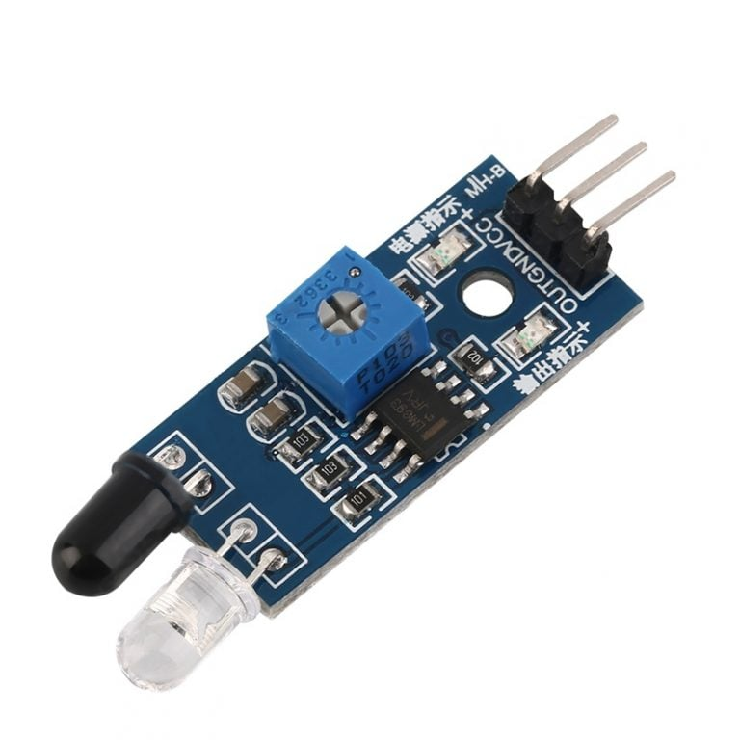

Figure 1 IR sensor

The emitter is simply an IR LED [(Light Emitting Diode](https://robu.in/product-category/display-boards/led/)) and the detector is simply an IR photodiode . Photodiode is sensitive to IR light of the same wavelength which is emitted by the IR LED. When IR light falls on the photodiode, the resistances and the output voltages will change in proportion to the magnitude of the IR light received. There are five basic elements used in a typical infrared detection system: an infrared source, a transmission medium, optical component, infrared detectors or receivers and signal processing. Infrared lasers and Infrared LED’s of specific wavelength used as infrared sources.

The three main types of media used for infrared transmission are vacuum, atmosphere and optical fibers. Optical components are used to focus the infrared radiation or to limit the spectral response.

## ****Types of IR Sensor****

There are two types of IR sensors are available and they are,

* Active Infrared Sensor
* Passive Infrared Sensor

### ****1-Active Infrared Sensor****

Active infrared sensors consist of two elements: infrared source and infrared detector. Infrared sources include the LED or infrared [laser diode](https://robu.in/product-category/electronic-module/laser-module/). Infrared detectors include photodiodes or phototransistors. The energy emitted by the infrared source is reflected by an object and falls on the infrared detector.

### ****2-Passive Infrared Sensor****

Passive infrared [sensors](https://robu.in/product-category/sensor/) are basically Infrared detectors. Passive infrared sensors do not use any infrared source and detector. They are of two types: quantum and thermal. Thermal infrared sensors use infrared energy as the source of heat. [**Thermocouples**](https://robu.in/product/max6675-thermocouple-sensor-module/), pyroelectric detectors and bolometers are the common types of thermal infrared detectors. Quantum type infrared sensors offer higher detection performance. It is faster than thermal type infrared detectors. The photo sensitivity of quantum type detectors is wavelength dependent.

## ****IR Sensor Working Principle****

There are different types of infrared transmitters depending on their wavelengths, output power and response time. An IR sensor consists of an IR LED and an IR Photodiode, together they are called as PhotoCoupler or OptoCoupler.

**IR Transmitter or IR LED**

Infrared Transmitter is a light emitting diode (LED) which emits infrared radiations called as IR LED’s. Even though an IR LED looks like a normal LED, the radiation emitted by it is invisible to the human eye.

The picture of an Infrared LED is shown below.

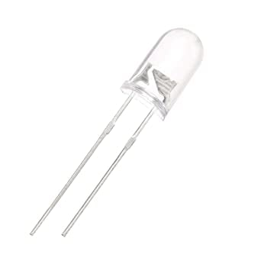

Figure 2 Infrared LED

**IR Receiver or Photodiode** Infrared receivers or infrared sensors detect the radiation from an IR transmitter. IR receivers come in the form of photodiodes and phototransistors. Infrared Photodiodes are different from normal photo diodes as they detect only infrared radiation. Below image shows the picture of an IR receiver or a photodiode,

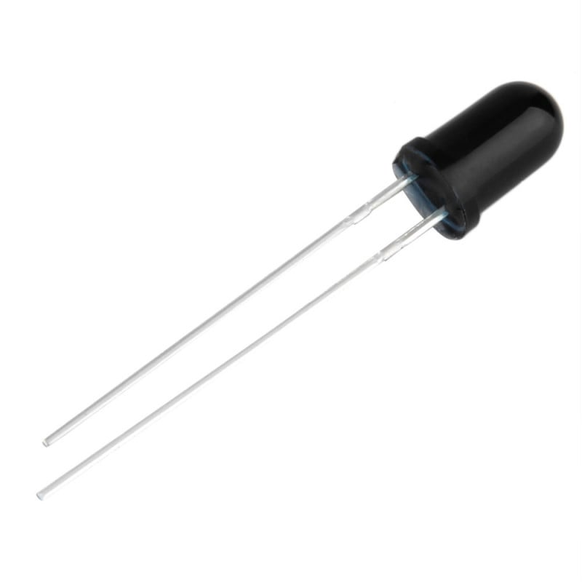

**Figure 3 IR receiver or a photodiode**

Different types of IR receivers exist based on the wavelength, voltage, package, etc. When used in an infrared transmitter – receiver combination, the wavelength of the receiver should match with that of the transmitter. The emitter is an IR LED and the detector is an IR photodiode. The IR photodiode is sensitive to the IR light emitted by an IR LED. The photo-diode’s resistance and output voltage change in proportion to the IR light received. This is the underlying working principle of the IR sensor.

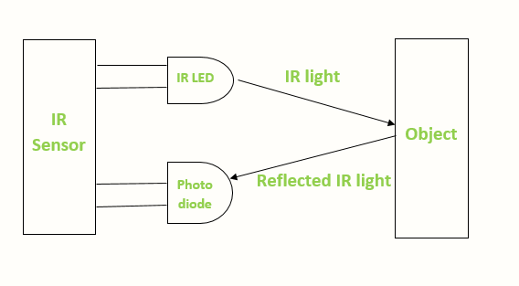 Figure 4 working principle of the IR sensor

**2.2 Ultrasonic Sensor**

The human ear can detect frequencies in a range from about 20 to 20 000 Hz Everything above 20 000 Hz is called ultrasonic and everything below 20 Hz is called infrasonic.An ultrasonic sensor uses a frequency of approximately 40 000 Hz. The sensor has one transmitter that emits a sound wave and one receiver that detects the wave that have bounced back from an object. The transmitter and the receiver together is a type of a transducer. A transducer converts physical energy to electrical and vice versa.The transmitter is like a speaker, it has a membrane that generates a sound wave.The electrical energy makes a membrane move, which generates a wave. The re-ceiver works in the same way, but opposite. The energy from a sound wave makes a membrane move which creates an electric signal.The sound wave has a certain scattering angle, this angle depends on the size of the membrane. a transmitter, “T” on the sensor and a receiver, ”R”on the sensor.

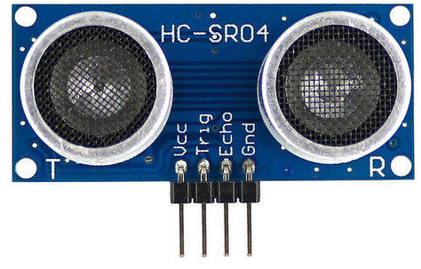

Figure 5 ultrasonic sensor

With help of the software, the distance can be calculated. This is done by taking the time from when the transmitter transmit to when the receiver gets a sound-wave back. With a temperature of 20 degrees the velocity of sound is 340 m/s .The distance can be calculated by:

L =v · t

Where t is the time and v is the velocity. The formula is divided by 2 because the sound-wave goes to the obstacle and back. Ultrasonic sensors have different applications. A transmitter can only make one type of sound wave, which is going to have a certain scattering angle and certain range. This angle and range, limitsan ultrasonic sensor to a specific application. The ultrasonic sensor is an electronic device used to measure distances. Because, measuring distance is an essential factor in many applications such as robotic control, Sensors such as optical and sound are the most helpful.

**Principle of Ultrasonic Sensor**

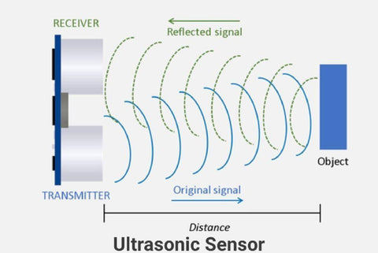

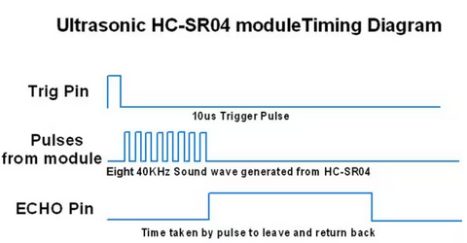

**Figure 6 Principle of Ultrasonic Sensor**

**2.2.1How Ultrasonic Sensors Work ?**

Ultrasonic sensors work by sending out a sound wave at a frequency above the range of human hearing. The transducer of the sensor acts as a microphone to receive and send the ultrasonic sound. Our ultrasonic sensors, like many others, use a single transducer to send a pulse and to receive the echo. The sensor determines the distance to a target by measuring time lapses between the sending and receiving of the ultrasonic pulse. The working principle of this module is simple. It sends an ultrasonic pulse out at 40kHz which travels through the air and if there is an obstacle or object, it will bounce back to the sensor. By calculating the travel time and the speed of sound, the distance can be calculated. **2.2.2 Why use an Ultrasonic Sensor?**

Ultrasound is reliable in any lighting environment and can be used inside or outside. Ultrasonic sensors can handle collision avoidance for a robot, and being moved often, as long as it isn’t too fast. Ultrasonic are so widely used, they can be reliably implemented in grain bin sensing applications, water level sensing, drone applications and sensing cars at your local drive- thru restaurant or bank. Ultrasonic rangefinders are commonly used as devices to detect a collision.

**2.3 Battery and Charging**

Batteries are probably the best solutions for electrification of a moving object.They can be recharged during activity by solar panels and during inactivity by a battery charger. Things to consider choosing batteries is the maximum continuous output

current and the maximum voltage it can provide. Also, the weight of the batteries can be a factor to consider.

The maximum continuous output current can be increased by parallel connection of batteries. The maximum output voltage can be increased by serial connection of batteries.

Common battery types in a lot of household machines are AAA, AA and A. Theses battery types can be rechargeable and have a continuous output current of 5000 mA for each battery cell.

Another common battery type is led accumulators, usually used in cars and bikes. They are also rechargeable and have often a higher continuous output current. A disadvantage is that they are heavier than the types above.

**2.4 MPU6050 Accelerometer and Gyroscope Sensor**

MPU6050 sensor module is complete 6-axis Motion Tracking Device. It combines 3-axis Gyroscope, 3-axis Accelerometer and Digital Motion Processor all in small package. Also, it has additional feature of on-chip Temperature sensor. It has I2C bus interface to communicate with the microcontrollers.

It has Auxiliary I2C bus to communicate with other sensor devices like 3-axis Magnetometer, Pressure sensor etc.

If 3-axis Magnetometer is connected to auxiliary I2C bus, then MPU6050 can provide complete 9-axis Motion Fusion output.

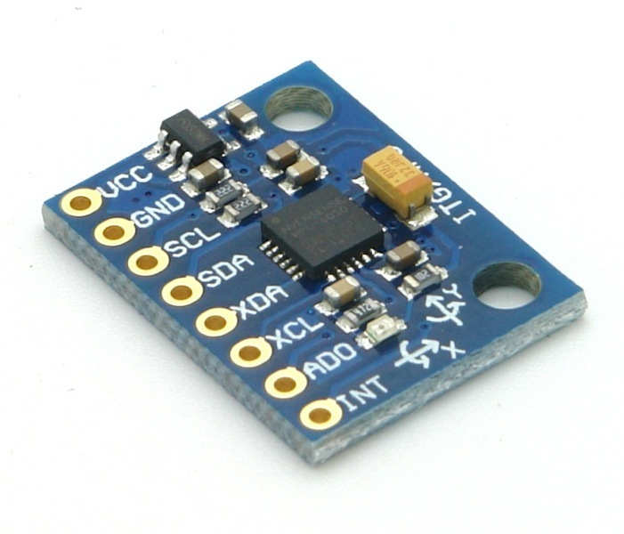

# **Figure 7 MPU6050**

# ****3-Axis Gyroscope****

The MPU6050 consist of 3-axis Gyroscope with Micro Electro Mechanical System(MEMS) technology. It is used to detect rotational velocity along the X, Y, Z axes.

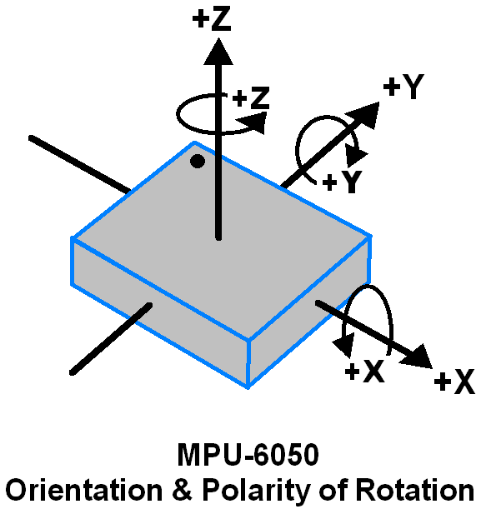

-  When the gyros are rotated about any of the sense axes, the Coriolis Effect causes a vibration that is detected by a MEM inside MPU6050.

- The resulting signal is amplified, demodulated, and filtered to produce a voltage that is proportional to the angular rate.

-  This voltage is digitized using 16-bit ADC to sample each axis.

-  The full-scale range of output are +/- 250, +/- 500, +/- 1000, +/- 2000.

-  It measures the angular velocity along each axis in degree per second unit.

# ****3-Axis Accelerometer****

The MPU6050 consist 3-axis Accelerometer with Micro Electro Mechanical (MEMs) technology. It used to detect angle of tilt or inclination along the X, Y and Z axes

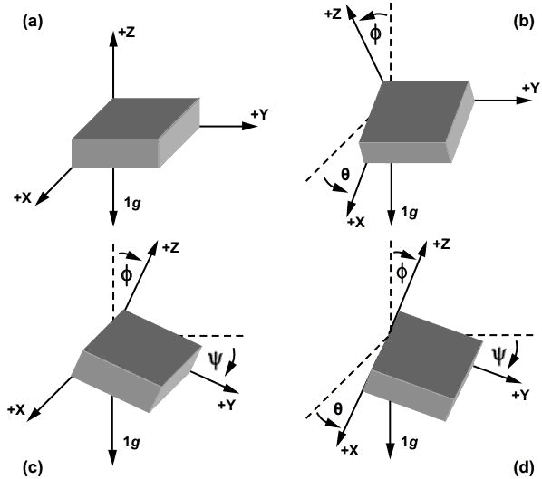

# **Figure 8 Axis Accelerometer**

-  Acceleration along the axes deflects the movable mass.

-  This displacement of moving plate (mass) unbalances the differential capacitor which results in sensor output. Output amplitude is proportional to acceleration.

-  16-bit ADC is used to get digitized output.

-  The full-scale range of acceleration are +/- 2g, +/- 4g, +/- 8g, +/- 16g.

-  It measured in g (gravity force) unit.

-  When device placed on flat surface it will measure 0g on X and Y axis and +1g on Z axis.

# ****MPU6050 Module Pinout****

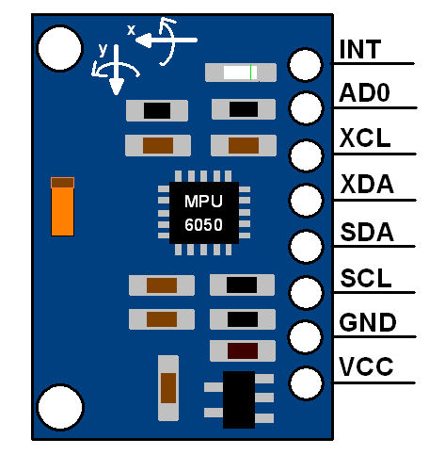

# ****Figure 9 MPU6050 Module Pinout****

# ****MPU6050 Pin Description****

The MPU-6050 module has 8 pins,

* **INT:**Interrupt digital output pin.
* **AD0:**I2C Slave Address LSB pin. This is 0th bit in 7-bit slave address of device. If connected to VCC then it is read as logic one and slave address changes.
* **XCL:**Auxiliary Serial Clock pin. This pin is used to connect other I2C interface enabled sensors SCL pin to MPU-6050.
* **XDA:**Auxiliary Serial Data pin. This pin is used to connect other I2C interface enabled sensors SDA pin to MPU-6050.
* **SCL:**Serial Clock pin. Connect this pin to microcontrollers SCL pin.
* **SDA:**Serial Data pin. Connect this pin to microcontrollers SDA pin.
* **GND:** Ground pin. Connect this pin to ground connection.
* **VCC:**Power supply pin. Connect this pin to +5V DC supply.
* MPU-6050 module has Slave address (When AD0 = 0, i.e. it is not connected to Vcc) as,
* **Slave Write address(SLA+W)**: 0xD0
* **Slave Read address(SLA+R)**: 0xD1

**2.5 comparator**

A comparator is an electronic circuit, which compares the two inputs that are applied to it and produces an output. The output value of the comparator indicates which of the inputs is greater or lesser. Please note that comparator falls under non-linear applications of ICs.

An op-amp consists of two input terminals and hence an op-amp based comparator compares the two inputs that are applied to it and produces the result of comparison as the output. This chapter discusses about op-amp based comparators.

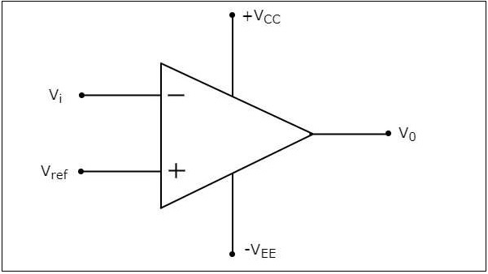

Figure 10 comparator

 the input and output waveforms of an inverting comparator, when the reference voltage is zero volts.

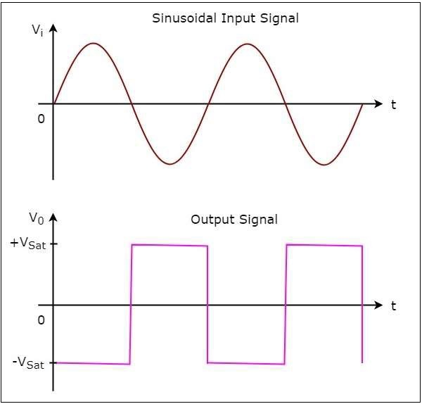

Figure 11 input and output of comparator

**2.6 Motors and motor driver**

**2.6.1 DC MOTOR**

A DC motor is any of a class of rotary electrical machines that converts direct current electrical energy into mechanical energy. The most common types rely on the forces produced by magnetic fields. Nearly all types of DC motors have some internal mechanism, either electromechanical or electronic, to periodically change the direction of current flow in part of the motor. DC motors were the first form of motor widely used, as they could be powered from existing direct-current lighting power distribution systems. A DC motor's speed can be controlled over a wide range, using either a variable supply voltage or by changing the strength of current in its field windings. Small DC motors are used in tools, toys, and appliances. The universal motor can operate on direct current but is a lightweight brushed motor used for portable power tools and appliances. Larger DC motors are currently used in propulsion of electric vehicles, elevator and hoists, and in drives for steel rolling mills. The advent of power electronics has made replacement of DC motors with ac motor possible in many applications.

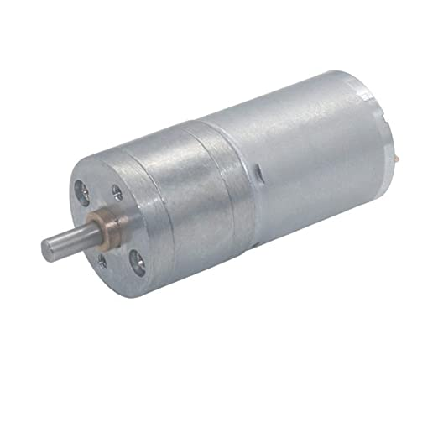

Figure 12 Dc Gear Motor

Dc motor is used in this project for the movement of wheel. High torque dc motor is used for the convenient movement of the wheel. As the weight of the automatic vacuum cleaner is approx 5-6 kg we need a series dc motor which generate high torque. Dc motor is also used for controlling the speed of wheel of automatic vacuum cleaner. Dc motor is used to convert direct electrical energy into mechanical energy. DC motor work on the principal that "whenever a current carrying conductor is placed in a magnetic field, it experiences a mechanical force”. The direction of the mechanical force induced in a dc motor is given by Fleming’s Left-hand Rule and its magnitude is given by F=BIL Newton. Dc motor is connected with NodeMcu Esp8266 with the help of dc motor driver, which is further connected to the battery. Dc motor can rotate in both clockwise and anticlockwise movement of the wheel.as the load driven by Dc motor is more so armature current needed by it will also be more as a result high torque dc motor is required so that it can bear a heavy load.

**2.6.2 DC MOTOR DRIVER**

A dc motor driver is a device that serves to conduct in some predetermined manner the performance of a dc motor. A dc motor driver can be use to control the starting and stopping or in forward or reverse rotation of a wheel, regulating the speed of the wheel, limiting the torque and protecting against overloads and faults either a manual or automatic. Common features of dc motor driver are:

• precise closed loop position control

• fast acceleration rates

• precise speed control dc motors may be made from several motor types, the most common being:

o brushed DC motor

o brushless DC motors

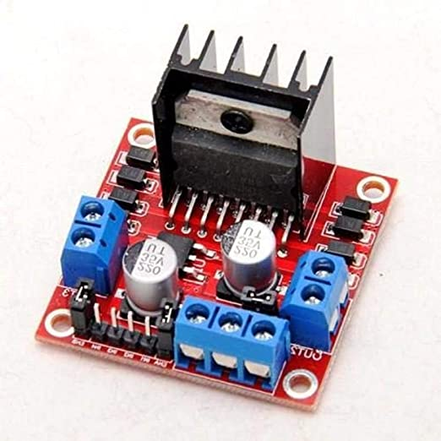

Figure 13 Motor Driver Module

is an integrated monolithic circuit in a 15- lead Multi-watt and PowerSO20 packages. It is a high voltage, high current dual full-bridge driver de-signed to accept standard TTL logic level sand drive inductive loads such as relays, solenoids, DC and stepping motors. Two enable inputs are provided to enable or disable the device independently of the in-put signals. The emitter of the lower transistors of each bridge are connected together rand the corresponding external terminal can be used for the connection of an external sensing resistor. An additional Supply input is provided so that the logic works at a lower voltage.

//Different types of electric motors such as DC (Direct Current) motors, AC (Alternating Current) motors, servo motors and stepper motors can be used in robotic applications. For vacuum cleaner robots, DC motors can be used for the movement of the robot, vacuuming, and brushes.

Motors have two important variables that must be considered depending on the application. These variables are the maximum speed and the torque. The speed and the torque of the motor are inversely proportional. Generally, DC motors have high speeds and low torque values. DC motors used on the vacuum cleaner robots must have enough torque to carry the weight of the robot and provide movement.

Motor drivers are used to control the motors in terms of speed, rotation direction, angle etc. DC motor drivers have H-bridge ICs which consist of MOSFETs or BJTs acting as switches. Simple H-Bridge circuit with a DC motor is given in Fig. 4. In this figure, S1, S2, S3 and S4 are the switches. Different states of these switches determine the direction of the DC motor either clockwise or anti-clockwise. They can also be used to brake the motor. In Fig. 4, assuming that the direction of rotation of the DC motor is clockwise when the current flows from the left to the right, the operations of the motor for some different states of the switches are given in Table 2. Switch state “1” meaning the switch is closed (ON) and switch state “0” meaning the switch is opened (OFF).



Figure 14 Simple H-Bridge

DC motors attached to wheels have been chosen in gear and micro size to provide sufficient torque for movement and take up small space on the robot body. High torque is required for the robot to move and carry its weight continuously. The voltage for geared DC motors has been selected as 6 V because if the required torque is provided with low voltage, the power consumption will be low. Motor speed has been chosen as 60 RPM that is enough for a vacuum cleaner robot. Also 3-6 V DC motor with gearbox is used for the rotation of the brush.

Table 2. H-bridge motor operations

|  |  |  |  |  |  |
| --- | --- | --- | --- | --- | --- |
| Operation | S4 | S3 | S2 | |  | | --- | | S1 | |
| Clockwise Direction | 1 | 0 | 0 | 1 |
| Anti-Clockwise Direction  Braking Mode | 0 | 1 | 1 | 0 |

The motor driver module “L298N” is used to control DC motors. This motor driver has dual H-bridge inside and it can control speed and direction at the same time individually with PWM.

**2.7 WHEEL**

Wheel is used for the movement of the body from one place to another with the help of Dc motor. A wheel is usually of circular shape and hard and made up of durable material whose center has a circular hole through which an axle bearing is placed about which the wheel rotates and when a moment is applied by the torque to the wheel about the axis, thereby making together and also easy movement of the automatic vacuum machine. When wheel is placed vertical axis under a load-bearing platform , the wheel turning on the horizontal axis makes it possible to transport heavy loads efficiently, when placed horizontally, the wheel turning on its vertical axis makes it possible to control the spinning motion used to shape materials , when mounted on a column connected to a chassis mounted on other wheels, one can control the direction of a automatic vacuum cleaner, when connected to a engine, a wheel control, release, or transmit energy .

**2.8 VACUUM CLEANER**

A vacuum cleaner, also known simply as a vacuum, is a device that causes suction in order to remove debris from floors, upholstery, draperies and other surfaces. It is generally electrically driven.

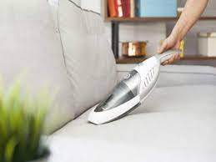

Figure 15 vacuum cleaner

The dirt is collected by either a dustbag or a cyclone for later disposal. Vacuum cleaners, which are used in homes as well as in industry, exist in a variety of sizes and models—small battery-powered hand-held devices, wheeled canister models for home use, domestic central vacuum cleaners, huge stationary industrial appliances that can handle several hundred litres of dust before being emptied, and self-propelled vacuum trucks for recovery of large spills or removal of contaminated soil. Specialized shop vacuums can be used to suck up both dust and liquid Most vacuum cleaners are supplied with numerous specialized attachments, such as tools, brushes and extension wands, which allow them to reach otherwise inaccessible places or to be used for cleaning a variety of surfaces. The most common of these tools are:

• Hard floor brush (for non-upright designs)

• Powered floor nozzle (for canister designs)

• Dusting brush

• Crevice tool

• Upholstery nozzle

**2.9 ESP32**

ESP32 is a low-cost, low-power system on a chip (SoC) microcontroller with integrated Wi-Fi and Bluetooth connectivity, developed by Espressif Systems. It is based on the Xtensa LX6 processor, which has two cores running at up to 240 MHz, and includes 520KB SRAM, 4MB Flash memory, and various peripheral interfaces, such as UART, SPI, I2C, I2S, and PWM.

ESP32 also features a built-in security module with support for AES, SHA-2, RSA, and ECC cryptographic algorithms, making it suitable for applications that require secure data communication. The Wi-Fi and Bluetooth connectivity is supported by multiple protocols, including 802.11b/g/n, BLE, and Classic Bluetooth.

ESP32 is widely used in various IoT applications, such as home automation, smart lighting, sensor networks, and industrial automation, due to its low power consumption, high performance, and rich set of features.

It is also supported by a large community of developers and enthusiasts, which provides extensive documentation, tutorials, and open-source libraries to help developers get started with their projects.

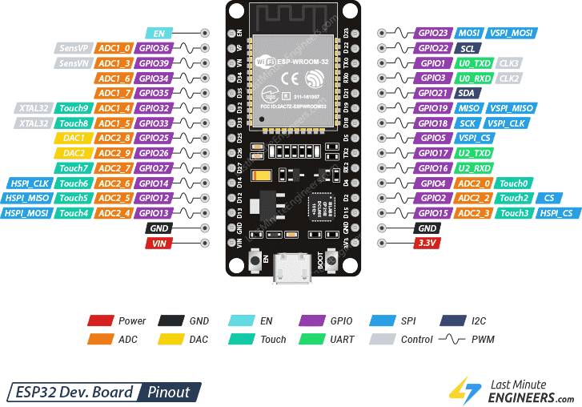

Feature and specifications

1. Processor: Dual-core Tensilica LX6 microprocessor with clock frequency of up to 240 MHz.
2. Memory: 520 KB of SRAM and 4 MB of flash memory.
3. Wireless Connectivity:
   * Wi-Fi 802.11 b/g/n with up to 150 Mbps data rate.
   * Bluetooth v4.2 BR/EDR and BLE (Bluetooth Low Energy) with a maximum transmission power of 20 dBm.
   * Supports multiple protocols including A2DP, AVRCP, SPP, GATT, and GAP.
4. Peripherals:
   * 12-bit SAR ADC with up to 18 channels.
   * 2 × 8-bit DAC.
   * 2 × I2C interfaces.
   * 3 × UART interfaces.
   * 2 × SPI interfaces.
   * 2 × I2S interfaces for audio applications.
   * 16 × PWM output.
   * 10 × capacitive touch sensing GPIOs.
   * SD/SDIO/CE-ATA/MMC/eMMC host controller with SDIO 3.0 support.
   * Ethernet MAC interface with dedicated DMA and IEEE 1588 support.
   * CAN 2.0 support.
5. Power Consumption:
   * Deep sleep mode with power consumption as low as 10 µA.
   * Modem sleep mode with power consumption as low as 2.5 mA.
6. Operating Voltage: 2.2V to 3.6V.
7. Operating Temperature: -40°C to 125°C.
8. Development Environment: Supports Arduino IDE, Espressif IDF (Integrated Development Framework), MicroPython, and Lua RTOS.Top of Form

The ESP32 is a versatile microcontroller that can perform a wide range of functions depending on the application requirements. Here are some common functions that the ESP32 can perform:

1. *Wireless Communication*: The ESP32 can be used to establish wireless communication using Wi-Fi and Bluetooth protocols. It can be used to connect to the internet, send/receive data, and control devices remotely.
2. *Sensor Data Acquisition and Processing*: The ESP32 has several built-in peripherals, including ADC, DAC, I2C, SPI, and UART interfaces, that can be used to acquire and process data from sensors. It can be used to measure temperature, humidity, light, motion, and other physical parameters.
3. *Actuator Control*: The ESP32 can be used to control various types of actuators, such as motors, relays, and LEDs. It can be used to build home automation systems, smart lighting systems, and other devices that require remote control.
4. *Data Logging*: The ESP32 can be used to log data from sensors and store it in its flash memory or an external SD card. It can be used to monitor environmental conditions, track machine performance, and perform other data logging tasks.
5. *Machine Learning*: The ESP32 can be used to perform machine learning tasks, such as pattern recognition, image processing, and classification. It can be used to build smart cameras, voice assistants, and other intelligent devices.
6. *Edge Computing*: The ESP32 can be used to perform edge computing tasks, such as data preprocessing, filtering, and aggregation. It can be used to reduce the amount of data transmitted over the network and improve the performance of IoT systems.

**2.9 lcd(i2c)**

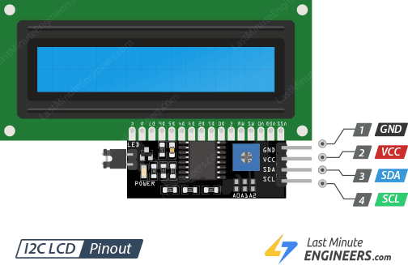

**Encoder with PID**

**Introduction**

An encoder in DC motors is a device used to measure and provide feedback about the motor's shaft position or speed

The encoder signals are typically processed by a control system or a microcontroller, which uses the feedback to adjust the motor's drive signals and maintain the desired position or speed. By comparing the feedback from the encoder with the desired setpoint, the control system can make necessary adjustments to achieve accurate motor control.

By itself, a DC motor can't be controlled like a servo motor or a stepper motor. But add an encoder, and you unlock the full potential of the DC motor. Using this approach, you can harness the simplicity, even torque, and lightweight profile of a DC motor for your controlled application.

**How encoder work?**

An encoder works by observing changes to the magnetic field created by a magnet attached the motor shaft. As the motor rotates, the encoder outputs will trigger periodically.

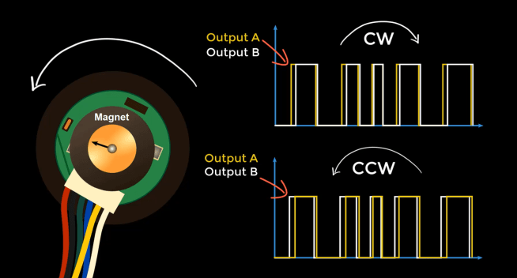

When the magnet spins clockwise, output A will trigger first.

When rotated counterclockwise, on the other hand, output B will trigger first.

connect the output pins of the encoder to pins with interrupts of the microcontroller.

triggers an interrupt when A rises, and then either adds one to the position (if output B is high) or subtracts one (if output B is low). *APPENDIX*

To ensure that the position variable is stored so that it can be accurately read by both the loop and interrupt functions, you need to use the **volatile** qualifier. The volatile keyword prevents the compiler from performing optimizations on the variable that could potentially lead to it being misread. In addition to the volatile directive, an ATOMIC_BLOCK macro is needed to access the position variable. The ATOMIC_BLOCK macro prevents the interrupt from changing part of the position variable while it is being read. Without the ATOMIC_BLOCK macro, it is possible for the interrupt to change part of the position while it is being read, leading to a completely different reading of the variable.

**Control the motor**

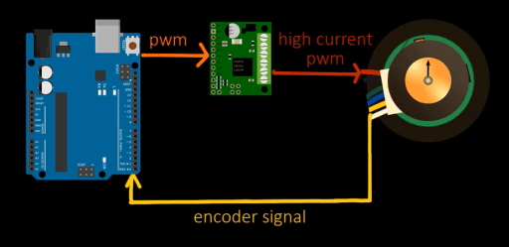

construct the feedback control loop

* Define a target position
* Compute the error e(t) as the difference between the measured position and the target
* Compute a control signal u(t)

The control signal u(t) can be computed using the PID (Proportional Integral Derivative) control algorithm. The control signal is computed as a sum of three terms:

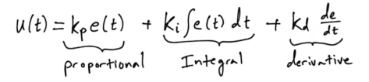

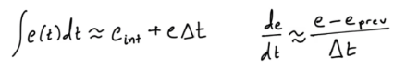

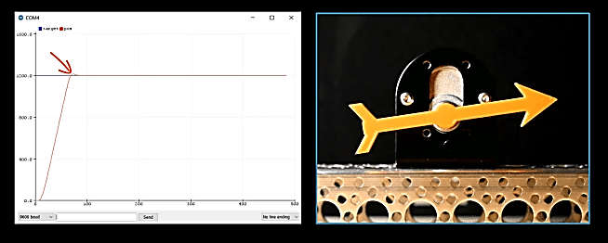

**Chapter3**

**3.1 Control Module**

**3.1.1 Arduino**

The open-source Arduino platform is used to create electrical projects. A physical programmable circuit board, or microcontroller, plus software called IDE (Integrated Development Environment), which is the primary text editor used for Arduino programming that runs on your computer and is used to create and upload computer code to the physical board.

Figure 16 Arduino UNO

The ATmega328P-based Arduino UNO is a microcontroller board. It contains 14 digital I/O pins (six of which are PWM outputs), 6 analogue inputs, a 16 MHz ceramic resonator, a USB connection, a power connector, an ICSP header, and a reset button. It comes with everything you need to support the microcontroller; simply connect it to a computer through USB or power it using an AC-to-DC converter or battery to get started.

Arduino may be used to develop interactive devices that accept input from a number of switches or sensors and operate a range of lights, motors, and other physical outputs. Both standalone and computer-based Arduino projects (such as those using Flash, Processing, or MaxMSP) are possible. The Arduino code is written in C++ and includes specific methods and functions. C++ is a computer language that is easy to understand. When you produce a ‘sketch' (Arduino code file), it is analyzed and compiled to machine language.

3.1.2 Why Arduino?

• Ready to Use

The primary benefit of Arduino is its structure, which is ready to use. The 5V regulator, a burner, an oscillator, a microcontroller, a serial communication interface, an LED, and headers for the connections are all included in the full package that is Arduino. You don't need to consider any additional interfaces or programmer connections when you're programming.

• Code examples

The library of examples included in the Arduino software is another significant benefit of the platform.

• Simple functions

While programming an Arduino, you'll notice certain features that make life really simple. The automated unit conversion feature of Arduino is another benefit. You may claim that unit conversions are not a concern when debugging. Just focus all of your effort on the key components of your initiatives. There are no adverse effects to be concerned about.

• Large community

There are several forums where people discuss the Arduino on the internet. Arduino is used by professionals, enthusiasts, and engineers to create their creations. You can simply obtain assistance with anything. Additionally, every single function of Arduino is explained on the official website.

** *Figure16 Arduino PIN***

**Technical specifications**





***Figure17 Arduino PINS_2***

**Arduino pins**

---Atmega328P Microcontroller

It is a high-performance, single-chip microcontroller made by Atmel. The microcontroller chip is an 8-bit AVR RISC device. There are 23 general-purpose I/O pins, 32 KB of read-write ISP flash memory, 2 KB of static RAM, 1 KB of EEPROM, and 32 KB of SRAM.

---Atmega16U2 Microcontroller

In the Arduino UNO, it serves as a USB to serial converter

It converts the input voltage to 5V. A voltage regulator's main function is to regulate the voltage level in the Arduino board. The regulator's output voltage stays stable and close to 5 volts even if the input supply voltage fluctuates in any way.

---Crystal Oscillator

It operates at a frequency of 16 MHz, giving the microcontroller the clock signal it needs to provide basic timing and control for the board.

----RESET Button

Every time we flash the code to the board, it is advised that we press this button.

----Barrel Jack

The Arduino board is powered by an external power source using the barrel jack, also known as the DC Power Jack. The manufacturer advises maintaining it between 7 and 12 volts even though it is often attached to an adaptor that runs between 5 and 20 volts.

**3.1.2 STM32(ARM cortex)**

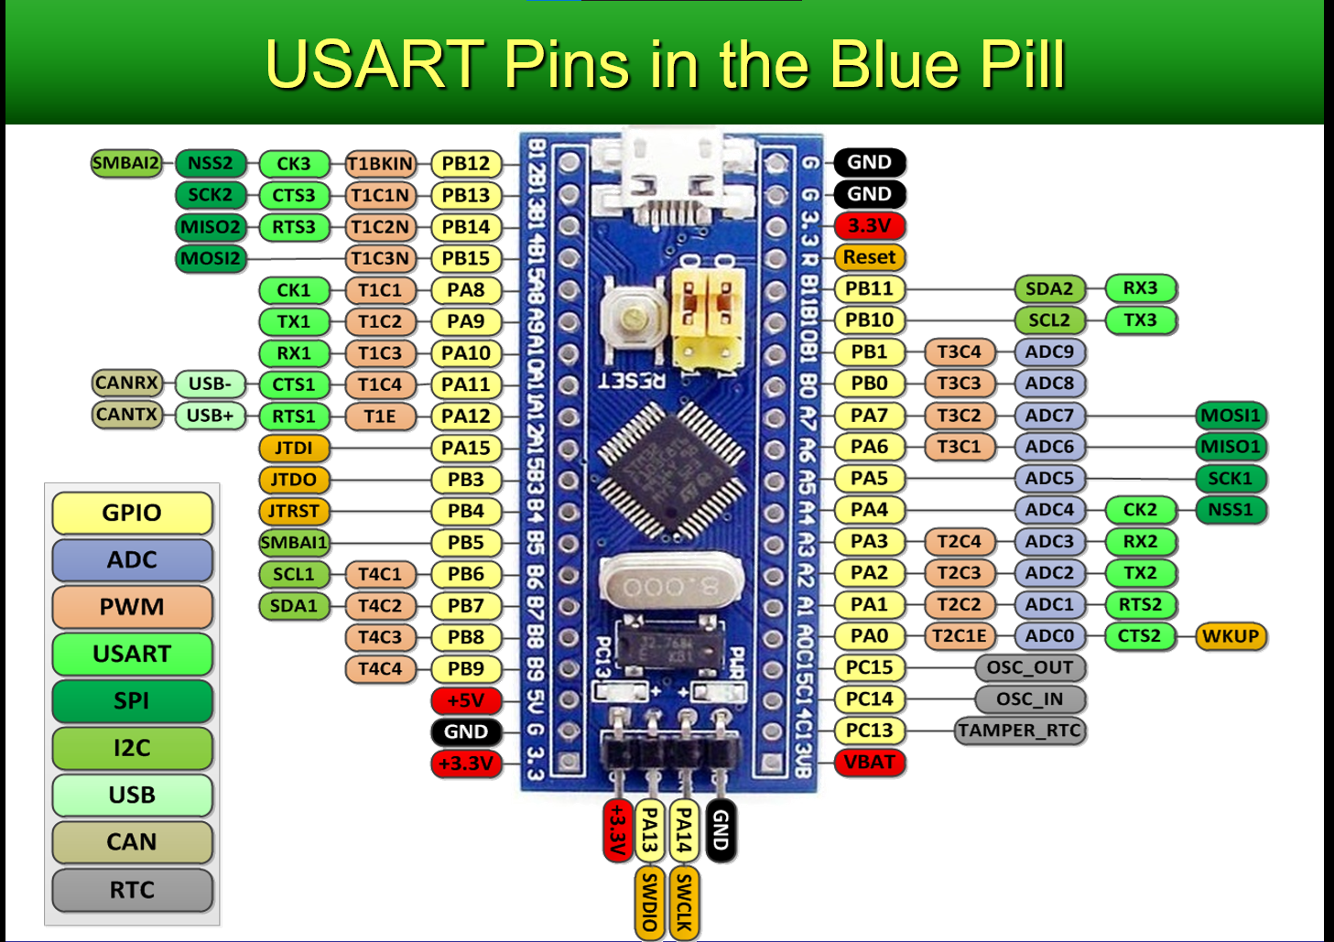

The STM32F103C6 is a microcontroller from STMicroelectronics' STM32F1 series, specifically part of the STM32F103xC family. It is based on the ARM Cortex-M3 core and offers a range of features suitable for various embedded applications. Here are some of its key features and specifications:

*1. Microcontroller Core:*

- ARM Cortex-M3 32-bit RISC core

- Maximum operating frequency of up to 72 MHz

- Single-cycle multiplication and hardware division

*2. Memory:*

- 32 KB Flash memory for program storage

- 6 KB of SRAM (Static Random Access Memory) for data storage

- Flash memory is programmable in single-word or single-page mode

*3. I/O and Peripherals:*

- Up to 37 General Purpose I/O (GPIO) pins, configurable as input/output

- Multiple timers/counters: 1 x 16-bit advanced-control timer, 2 x 16-bit general-purpose timers, and 1 x 16-bit basic timer

- 2 x I2C (Inter-Integrated Circuit) interfaces

- 3 x USART (Universal Synchronous/Asynchronous Receiver/Transmitter) interfaces

- 1 x SPI (Serial Peripheral Interface) interface

- 1 x USB 2.0 Full-Speed interface (12 Mbps)

*4. Analog:*

- 10-bit ADC (Analog-to-Digital Converter) with up to 10 channels

- 2 x 12-bit DAC (Digital-to-Analog Converter)

*5. Communication Interfaces:*

- CAN (Controller Area Network) 2.0B interface

- I2S (Inter-IC Sound) interface for audio applications

- SDIO (Secure Digital Input/Output) interface for SD cards and multimedia cards

*6. Power Supply:*

- Voltage supply range: 2.0V to 3.6V

- Low-power modes for energy efficiency

*7. Development and Debugging:*

- JTAG and SWD (Serial Wire Debug) interfaces for programming and debugging

- In-system programming (ISP) and in-application programming (IAP) support

**PID**

PID stands for "Proportional-Integral-Derivative," and it is a control algorithm widely used in engineering and industrial automation systems. The purpose of a PID controller is to regulate a process or system by adjusting an actuator (such as a valve or motor) based on feedback from sensors.

The PID controller continuously calculates an error signal, which represents the difference between the desired setpoint and the actual value of the process variable being controlled. The controller then adjusts the actuator output in response to this error signal, aiming to minimize the deviation and bring the process variable closer to the setpoint.

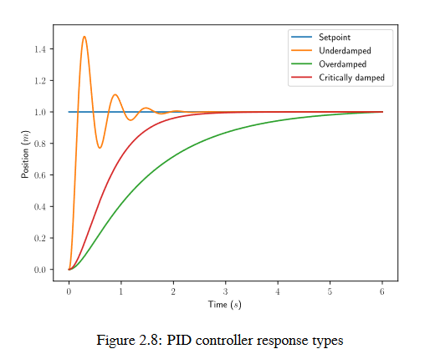

***The three components of a PID controller are as follows:***

* Proportional (P) Control: The proportional term produces an output that is proportional to the current error. It acts to reduce the error by applying a corrective action that is directly proportional to the magnitude of the error. However, proportional control alone can lead to steady-state error and overshoot.

**P(t) = Kp * e(t)**

Where:

P(t) = Proportional term output at time t

Kp = Proportional gain

e(t) = Error at time t (difference between setpoint and process variable)

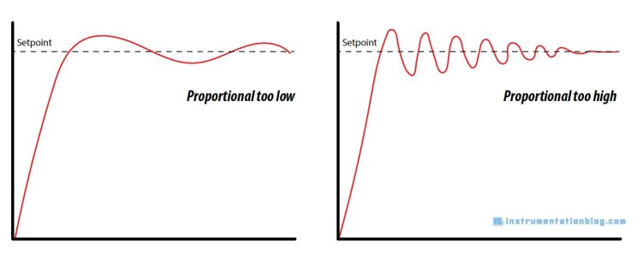

* Integral (I) Control: The integral term sums up the error over time and generates an output that is proportional to the accumulated error. It helps to eliminate steady-state error by continuously adjusting the control signal based on past errors. The integral term also helps in responding to sustained errors or long-term disturbances.

**I(t) = Ki * ∫ e(t) dt**

Where:

I(t) = Integral term output at time t

Ki = Integral gain

∫ = Integral symbol (represents the integration with respect to time)

e(t) = Error at time t

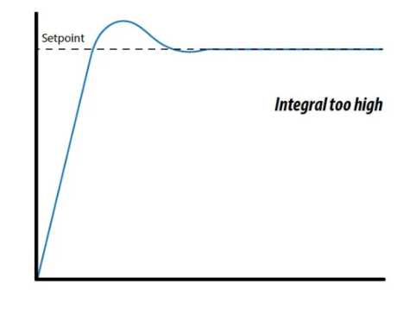

* Derivative (D) Control: The derivative term predicts the future trend of the error by calculating the rate of change of the error. It introduces a damping effect that reduces overshoot and improves stability by counteracting rapid changes in the process variable. The derivative term is beneficial in systems with fast dynamics or when quick responses are required.

***D(t) = Kd * de(t)/dt***

Where:

D(t) = Derivative term output at time t

Kd = Derivative gain

de(t)/dt = Rate of change of error with respect to time

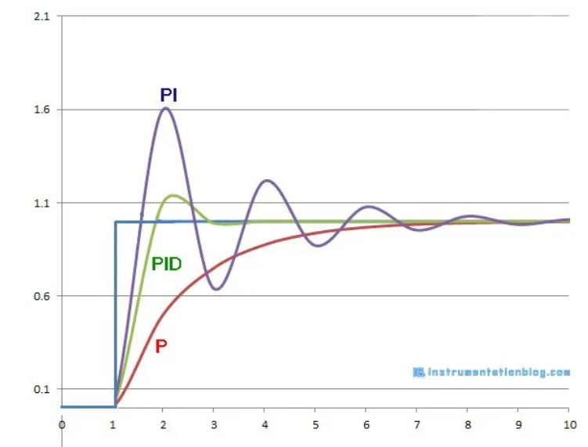

The PID controller combines these three components using appropriate gains or tuning parameters. The gains determine the contribution of each component to the overall control action. Tuning a PID controller involves adjusting these gains to achieve desirable system performance, such as stability, responsiveness, and robustness.

**u(t) = P(t) + I(t) + D(t)**

Where:

u(t) = Control output at time t

The gains (Kp, Ki, Kd) in the PID controller need to be tuned to achieve the desired system response and performance. The tuning process involves adjusting these gains based on the system's characteristics, such as stability, settling time, overshoot, and robustness, among others.

PID controllers are widely used in various applications, including temperature control, pressure regulation, speed control of motors, level control, and many other industrial processes where precise control is required

* various methods available for PID controller tuning, including *manual tuning*, *Ziegler-Nichols method*, and *model-based approaches*.

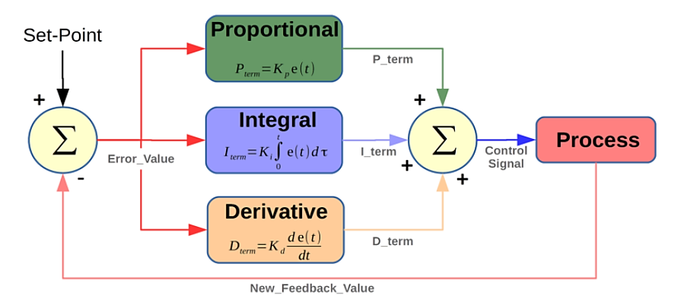

**CHAPTER 5**

**APPLICATION OF ROBOTIC VACUUM CLEANER**

• For household purposes:

It can be used for reducing the human contact with dust.

• For agriculture purposes:

The robot can be useful in the field of agriculture. It can be used for collecting

grains from soils.

• Robotic Vacuum Cleaner can be used in cleaning purposes in commercial areas

like restaurant, hospitals, shopping malls, highways, etc.

• It can be integrated with a powerful drier to dry up a wet surface**.**

**CHAPTER 6**

**CONCLUSION**

CONCLUSION

Our Project entitled “Robotic Vacuum Cleaner” was successfully completed as per our expectations and specifications. The operation of surface cleaning, obstacle avoidance and edge detection and avoidance was also successfully conducted. This project was started with the objective to embed vacuum cleaner in a robotic car and use it in various places for cleaning as well as survellience using video feedback, assisting humans by avoiding direct human contact with dust.

Our project in wireless communication of RF module gave us great knowledge about

the serial communication, RF transmission and reception, motor driving mechanism

and sensor based programming and operation. We have completed a prototype of a

cleaning robot despite of various complexities and also leaving various options behind

for further enhancements.

**CHAPTER 7**

**RECOMMENDATION AND FUTURE ENHANCEMENT**

1. We can use high powered RF module for long distance wireless communication

2. We can use high powered torque motors in order to provide sufficient torque to

drive motors under heavy loaded condition

3. Robotic arm can be added to the vehicle in order to pick up waste which are

bigger in size than the capacity of the vacuum cleaner

4. We can develop a scheduler to program the robot to automatically clean at

scheduled times.

5. A concept of home base can be developed so that the robot can be programmed

to return and dock to its charging station after completing its task

6. Our vehicle can be enhanced to a voice controlled locomotion using advanced

speech recognition software.

**iii. ‘S’ shaped pathway**

algorithm is the fastest process to cover the entire room are

. With every collision with obstacle the turning

direction of the robot continuously changes under this mode



shape pattern motion path s""

The robot has circular body structure. For this algorithm, after

every collision the robot has a sequence of movements. The are

a )Back

b. 900 Turn (Right/Left(

d. 900 Turn (Left/Right)



